Retrieve everything from a table

Code: Select*from cd.facilities

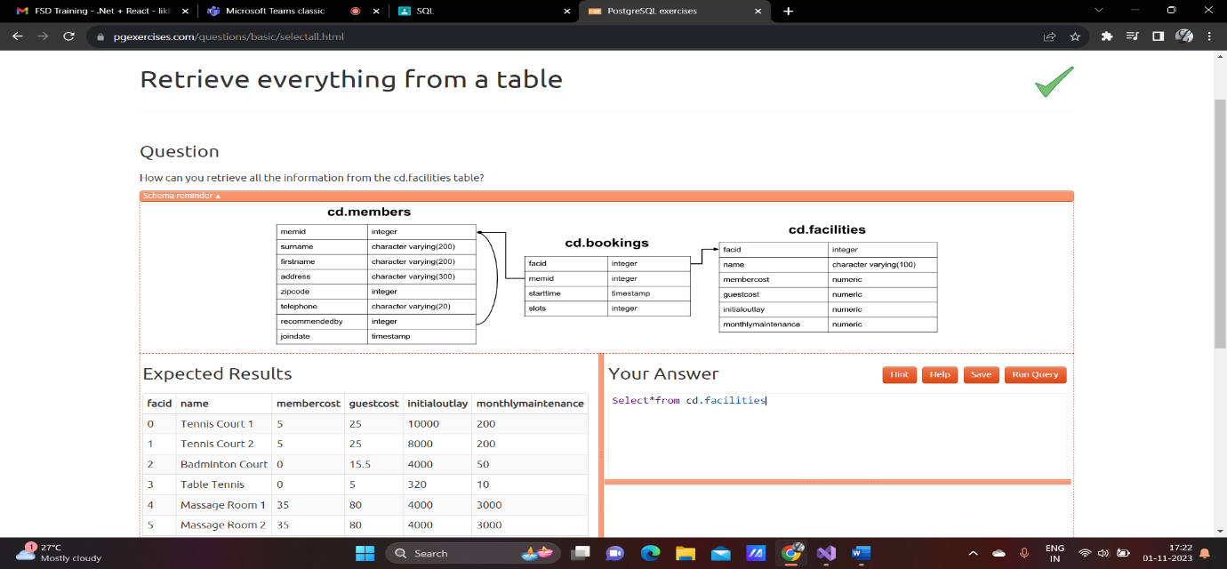

Retrieve specific columns from a table

Code:

select name,membercost from cd.facilities

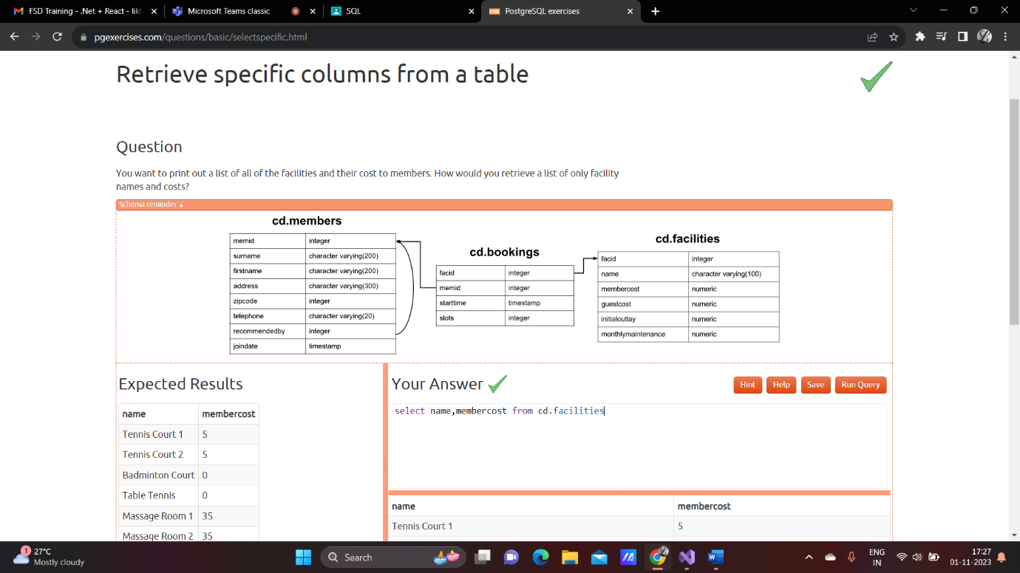

Control which rows are retervied

Code: select*from cd.facilities where membercost>0;

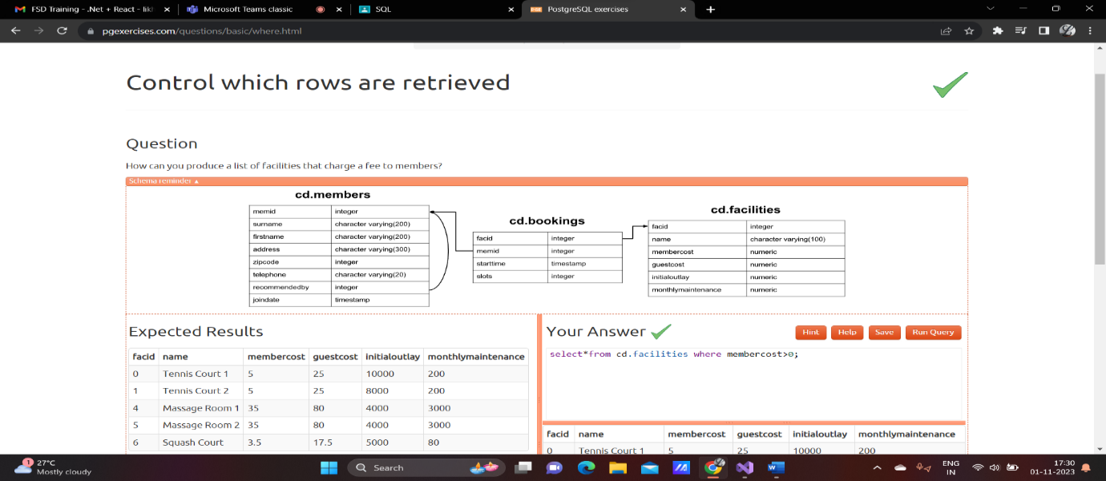

Control which rows are retervied-part-2

Code: select facid, name, membercost, monthlymaintenance from cd.facilities

where membercost > 0 and (membercost < monthlymaintenance/50.0);

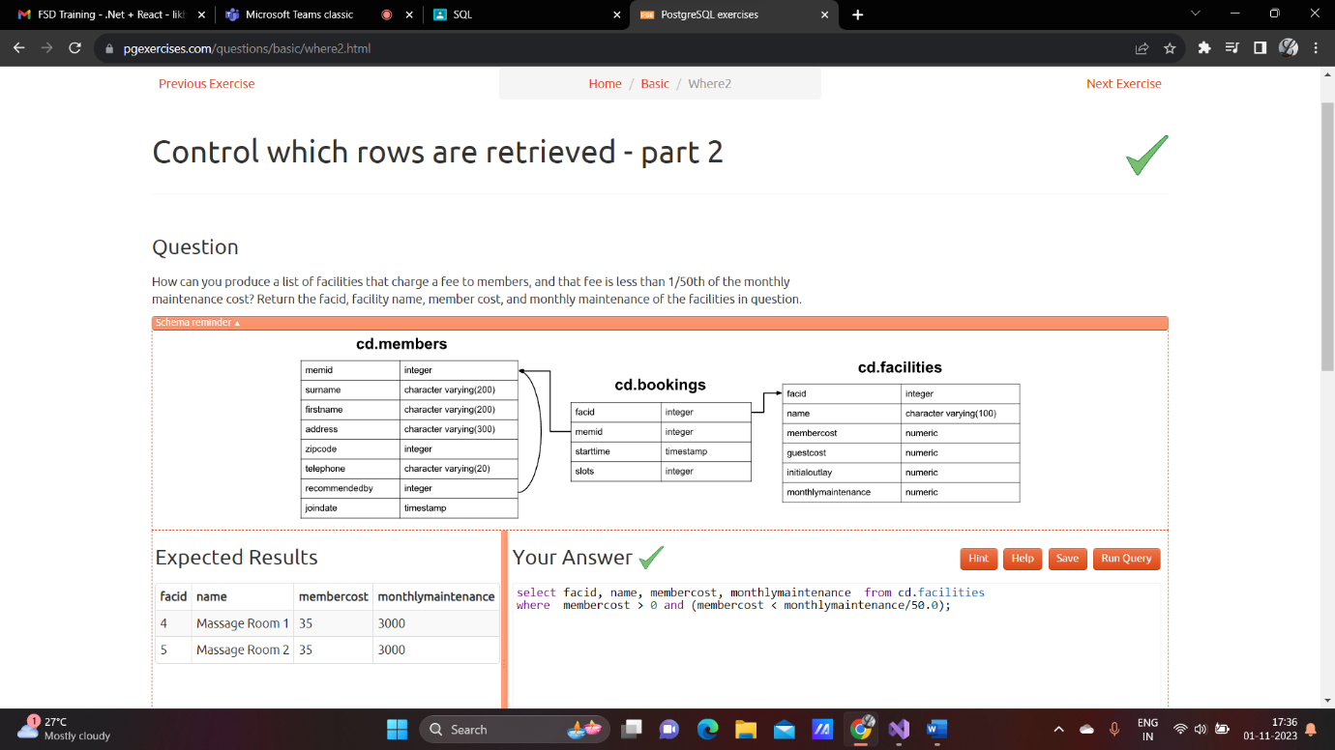

Basic string searches

Code: select*from cd.facilities where name like '%Tennis%';

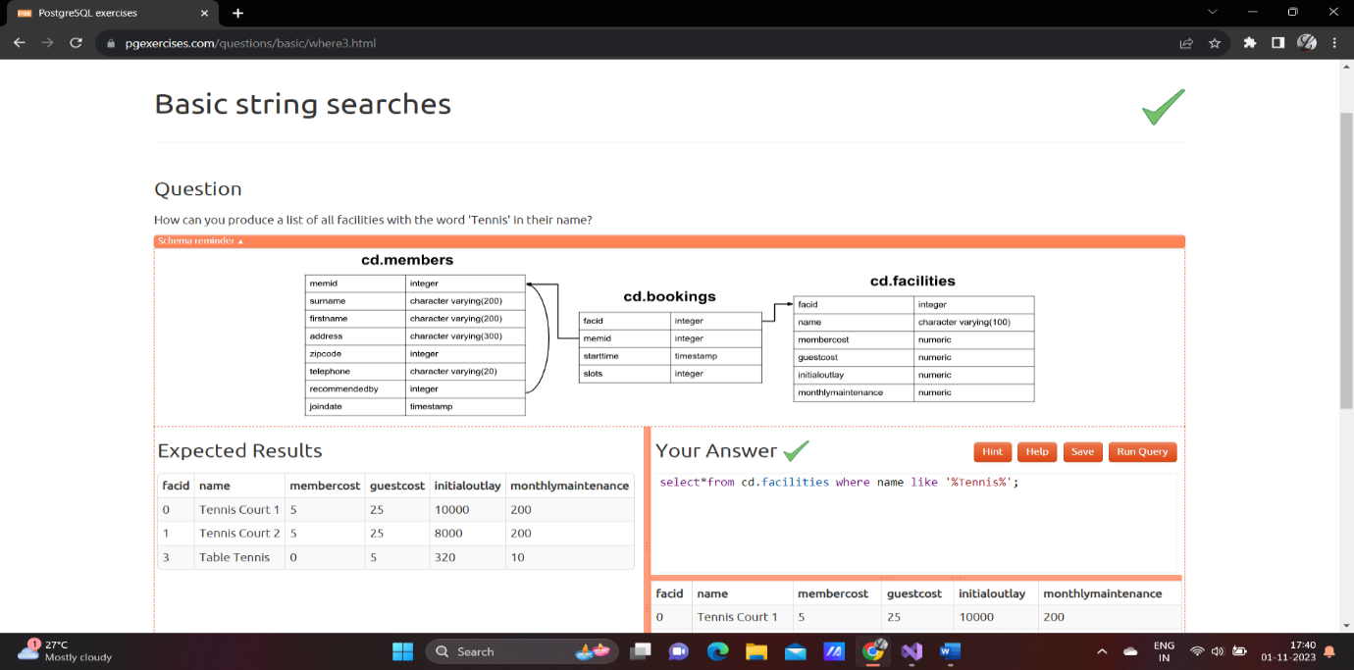

Matching against multiple possible values

Code: select*from cd.facilities where facid in (1,5)

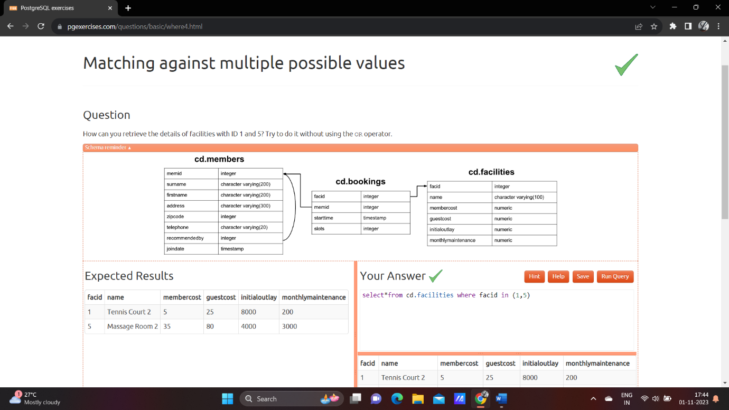

Classify results into buckets

Code: select name,

case when (monthlymaintenance > 100) then'expensive'

else 'cheap'

end as cost

from cd.facilities;

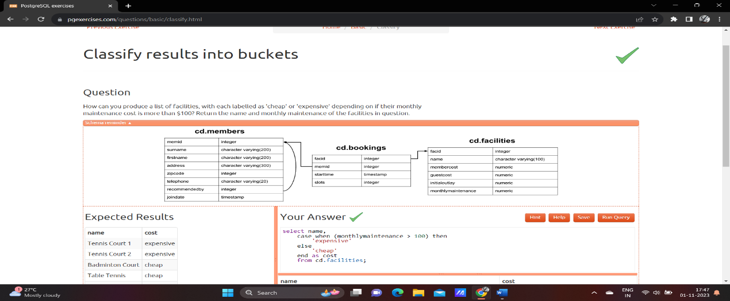

Working with date

Code: select memid, surname, firstname, joindate from cd.members

where joindate >= '2012-09-01';

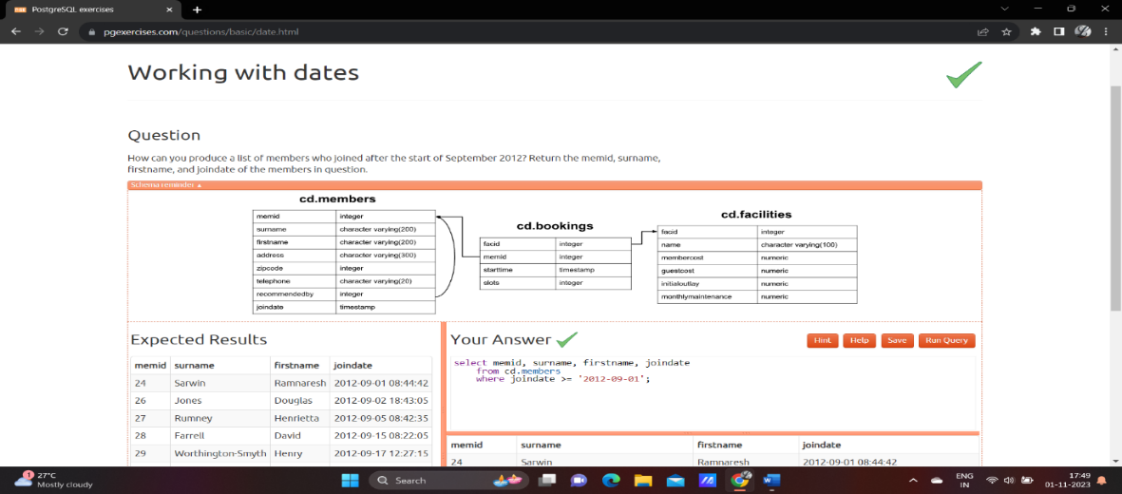

Removing duplicates and ordering results

Code: select DISTINCT(surname) from cd.members order by surname limit 10;

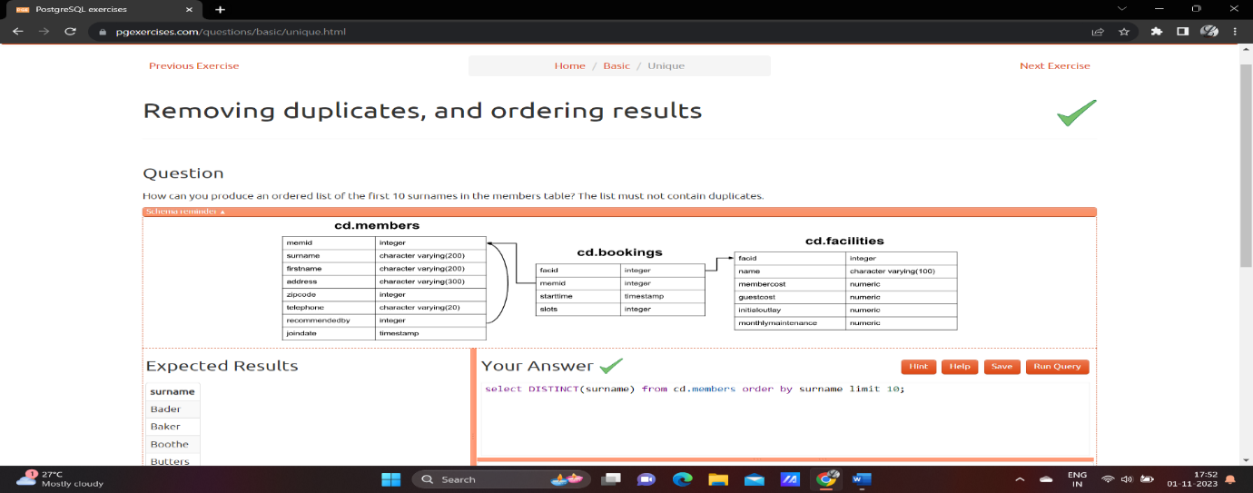

Combining results for multiple queries

Code: select surname from cd.members union select name from cd.facilities;

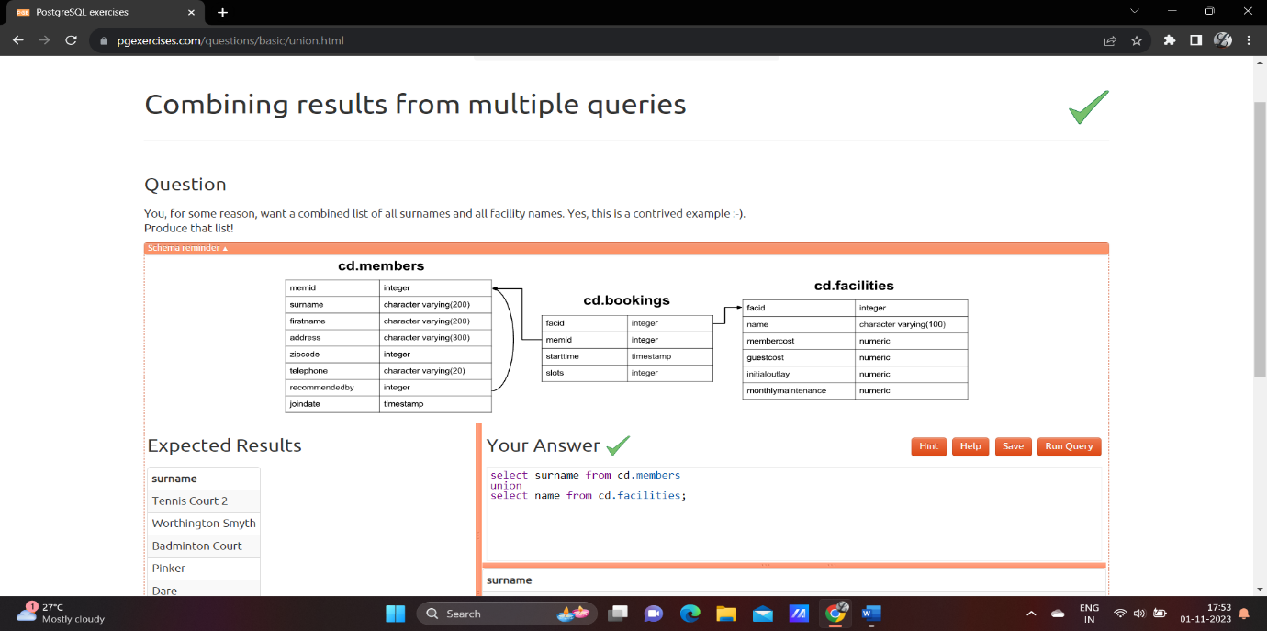

Simple aggregation

Code: select max(joindate) as latest from cd.members;

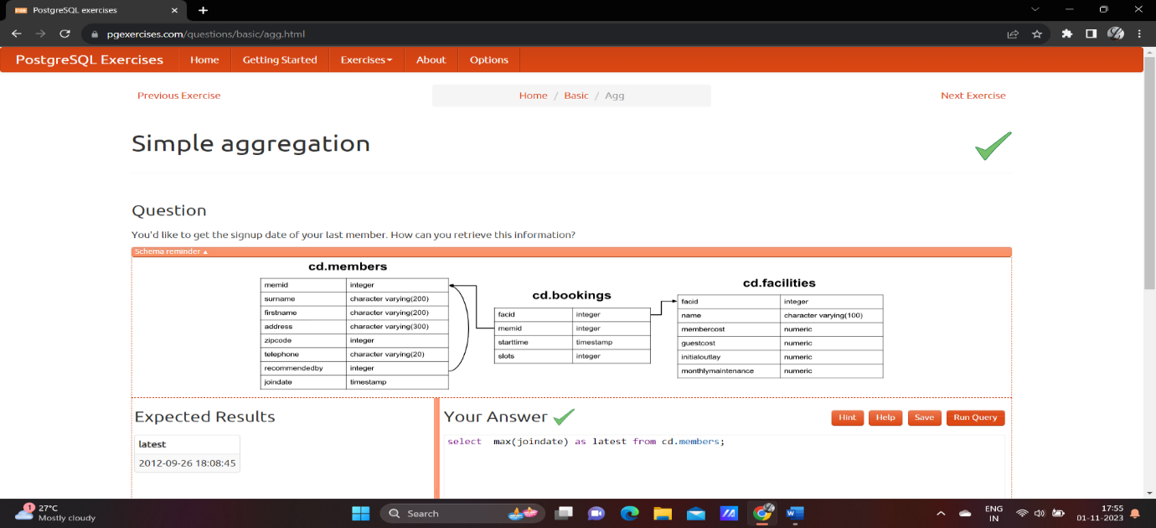

More aggregation

Code: select firstname, surname, joindate from cd.members

where joindate = (select max(joindate) from cd.members);

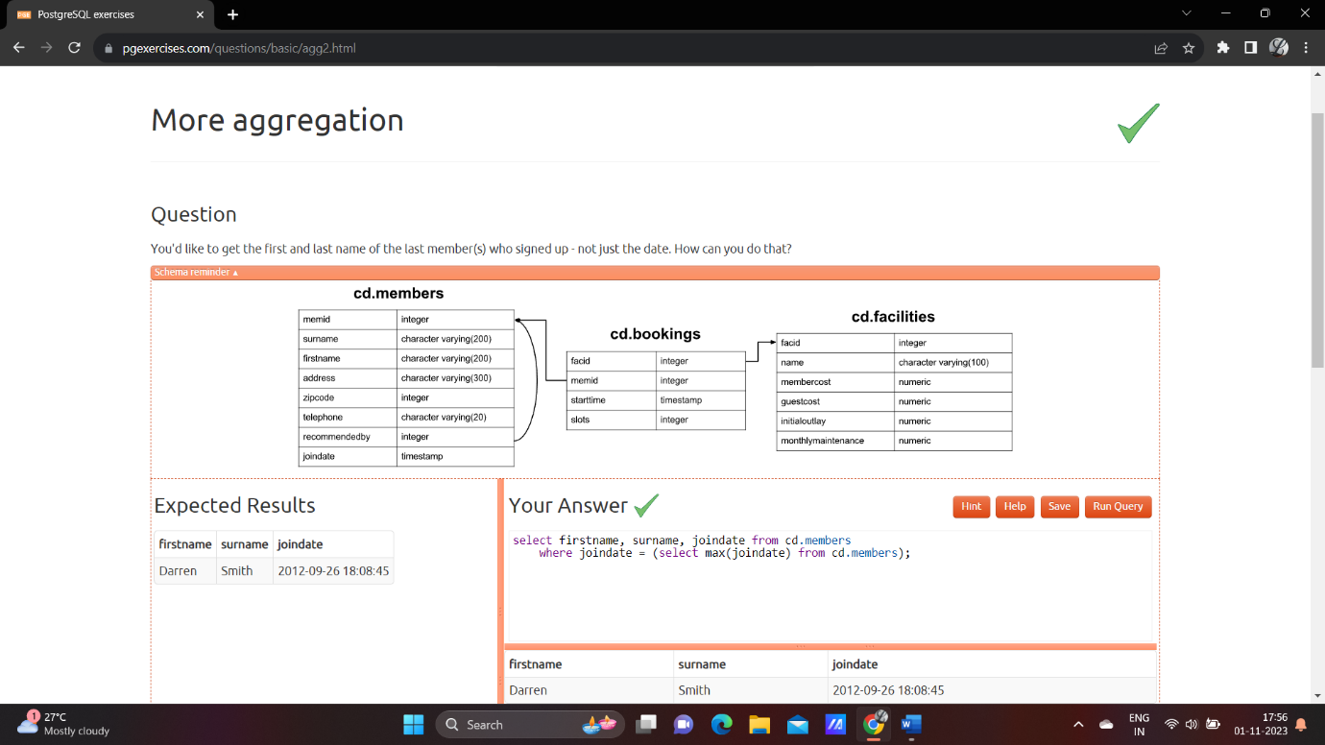

**Joins &sub query**

Produce alist of all members who have used a tennis court

Code: select distinct recs.firstname as firstname, recs.surname as surname

from cd.members mems

inner join cd.members recs

on recs.memid = mems.recommendedby

order by surname, firstname;

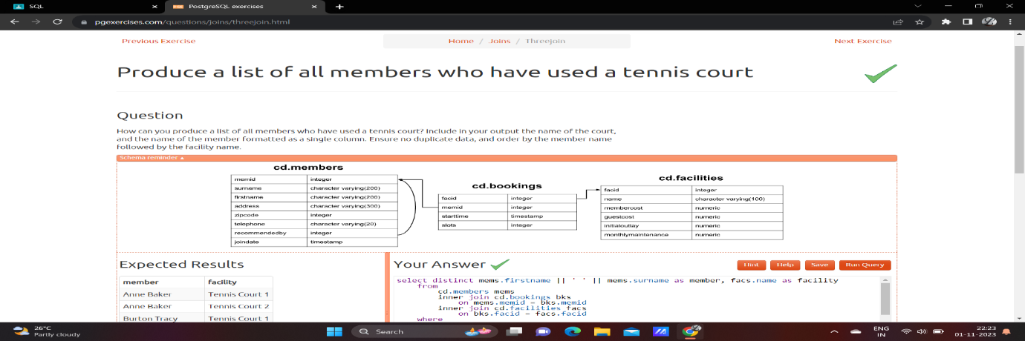

Work out the start times of booking for tennis courts

Code: select bks.starttime as start, facs.name as name

from cd.facilities facs

inner join cd.bookings bks

on facs.facid = bks.facid

where facs.name in ('Tennis Court 2','Tennis Court 1') and

bks.starttime >= '2012-09-21' and

bks.starttime < '2012-09-22'

order by bks.starttime;

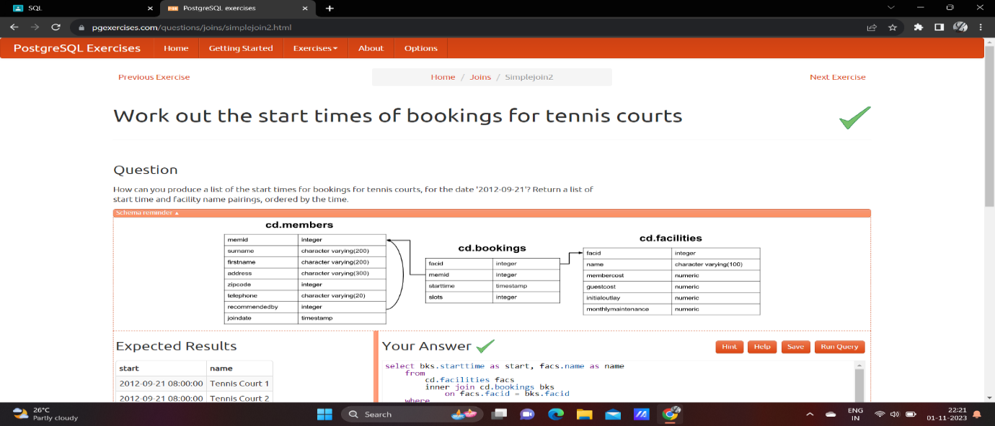

Produce a list of all members who have recommended another member

Code: select mems.firstname as memfname, mems.surname as memsname, recs.firstname as recfname, recs.surname as recsname

from cd.members mems

left outer join cd.members recs

on recs.memid = mems.recommendedby

order by memsname, memfname;

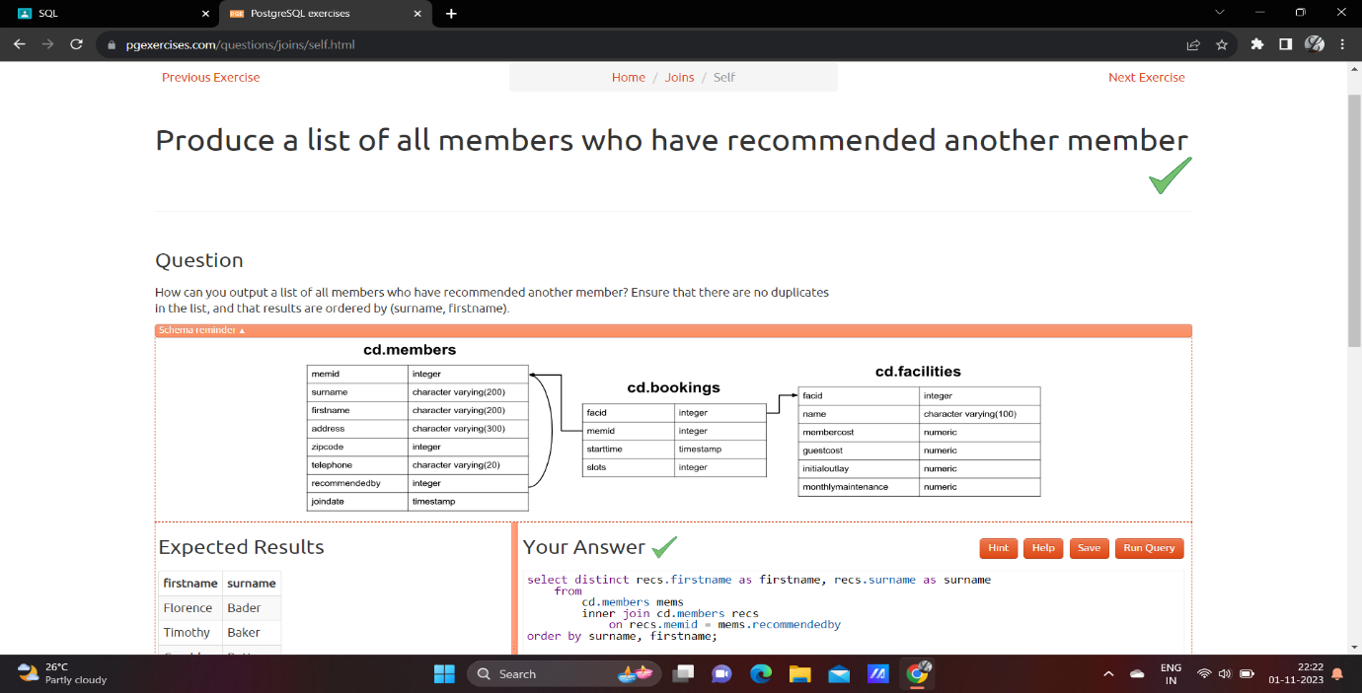

Produce a list of all members, along with their recommender

Code: select mems.firstname as memfname, mems.surname as memsname, recs.firstname as recfname, recs.surname as recsname

from cd.members mems

left outer join cd.members recs

on recs.memid = mems.recommendedby

order by memsname, memfname;

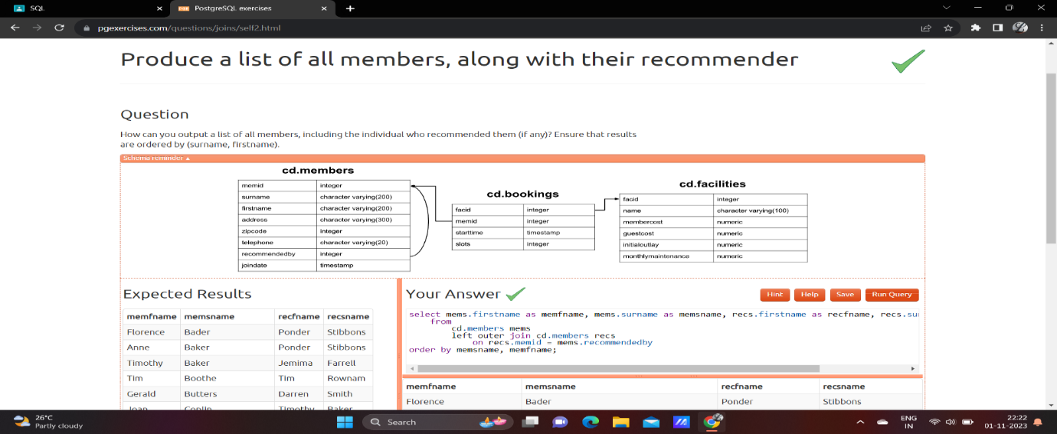

Produce a list of costly bookings

Code:

select mems.firstname || ' ' || mems.surname as member,

facs.name as facility,

case when mems.memid = 0 then bks.slots*facs.guestcost

else bks.slots*facs.membercost

end as cost

from cd.members mems

inner join cd.bookings on mems.memid = bks

inner join cd.facilities facs on bks.facid = facs.facid

where bks.starttime >= '2012-09-14' and

bks.starttime < '2012-09-15' and (

(mems.memid = 0 and bks.slots*facs.guestcost > 30) or

(mems.memid != 0 and bks.slots*facs.membercost > 30))

order by cost desc;

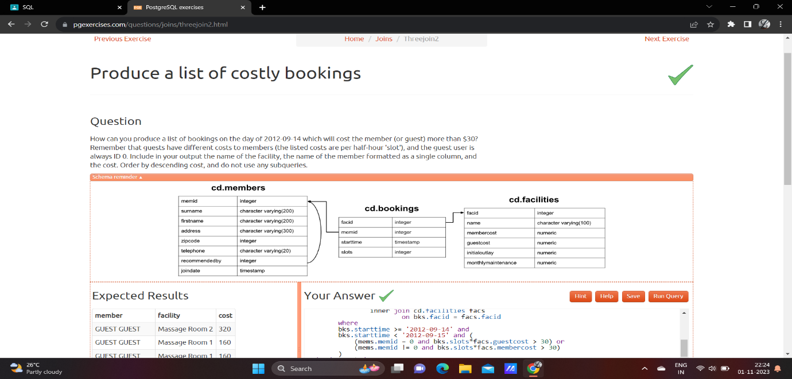

Produce a list of all members, along with their recommender, using no joins

Code:

select distinct mems.firstname || ' ' || mems.surname as member,

(select recs.firstname || ' ' || recs.surname as recommender

from cd.members recs

where recs.memid = mems.recommendedby)

from cd.members mems

order by member;

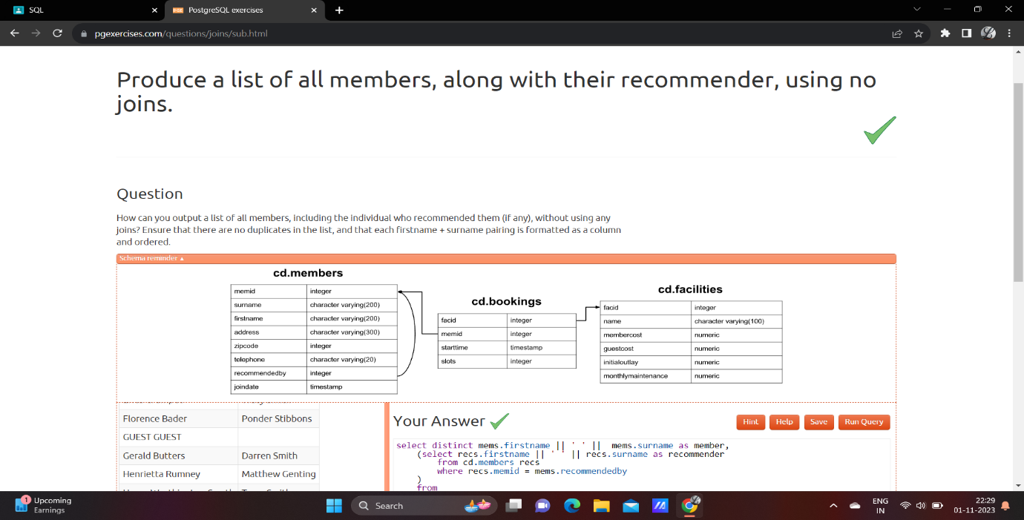

[Produce a list of costly bookings, using a subquery](https://pgexercises.com/questions/joins/tjsub.html)

Code: select member, facility, cost from (

select

mems.firstname || ' ' || mems.surname as member,

facs.name as facility,

case when mems.memid = 0 then

bks.slots*facs.guestcost

else bks.slots*facs.membercost

end as cost

from cd.members mems

inner join cd.bookings bks on mems.memid = bks.memid

inner join cd.facilities facs on bks.facid = facs.facid

where

bks.starttime >= '2012-09-14' and

bks.starttime < '2012-09-15') as bookings

where cost > 30

order by cost desc;

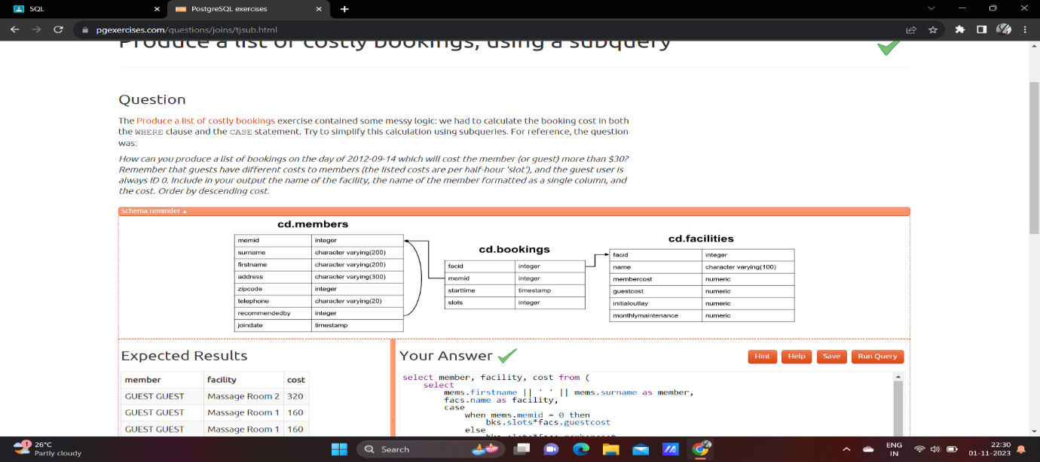

Retrieve the start times of members bookings

Code: select bk.starttime from cd.bookings bk inner join cd.members me on me.memid=bk.memid where me.firstname='David' and me.surname='Farrell';

